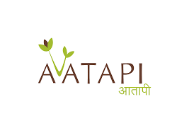

**PROJECT REPORT ON**

**SOCIO-ECONOMIC STATUS AND HEALTH OF FARMING WOMEN, AND IMPACT ASSESMENT OF DRUDGERY REDUCTION TOOLS**

**(Year 2021)**

**DEPARTMENT OF STATISTICS**

**FACULTY OF SCIENCE**

**THE MAHARAJA SAYAJIRAO UNIVERSITY OF BARODA**

**GUIDED BY : TEAM MEMBERS :**

**Dr. MANISHA PANDYA DIPAK BARIYA**

**Mr. SHREY PANDYA DARPAN PADARIA**

**VISHAL HARIJAN**

**RAJDEEP CHHASTIYA**

**CONTENTS**

* **INTRODUCTION**
* **REVIEW OF LITERATURE**
* **NEED FOR STUDY**
* **OBJECTIVES**
* **METHODOLGY**
  + **SOURCE OD DATA**
  + **TARGET POPULATION**
  + **SURVEY DESIGN**
* **SAMPLING METHOD**
* **ANALYSIS**
* **REFERENCES**

**INTRODUCTION**

India is a developing country. The main occupation is agriculture, because 70 per cent of the population is involved in this occupation. Many women in developing countries are occupied in agriculture. The rural women play a significant role in agriculture and other agro based activities. The daily work schedule of rural women is very demanding and arduous. Also in agriculture women are the major workers assigned the heavy drudgery work, such as weeding, watering, harvesting, carrying head loads, etc. And not in the least, environmental degradation influences their tasks by making it necessary to go further for water and fuel, leaving them less time for other work, such as work for an income (employment or self-employment). The situation in India is not better than that described here for a large part of the world.

Such work is often called “drudgery work”, which means dull and boring work, but it is also heavy work, back-breaking work, often dangerous work. Women themselves consider this drudgery work as normal, which is in fact part of the problem.

Hence, an urgent need to make women aware about latest drudgery reducing tools, implements and other technologies and motivate them to adopt the same was felt. If appropriate drudgery reduction technologies are made available to the farmwomen at home and farm, it would definitely contribute in reducing their drudgery, increasing their working capability, increasing farm production resulting in improved quality of life. To increase agricultural production, processing, marketing and generate livelihood opportunities, it is necessary to trained women farmers to use traditional and modern ICT tools to improve their working efficiency.

The general trend existing in rural India is limited resources available to women because of low socio-economic status in the society and within that limited access to resources, there exists a strong disparity that, most of the women’s earnings goes towards nutritional security of the households.

Most women cannot invest in the technology. Introduction to new technologies in agricultural operation adopted by farm women leading to the mechanization will reduce the drudgery and improve the efficiency.

Aatapi Seva Foundation strives to facilitate the holistic and sustainable development on socio-economic status, health of farming women and impact assessment of drudgery reduction tool through need based intervention voiced by the community.

**REVIEW OF LITERATURE**

**Drudgery Reduction**

* Women as farmer or farm workers, participate in several activities such as seeding, transplanting, weeding, fertilizer & manures application, plant protection, thinning, harvesting, processing, selling, winnowing, storing, etc. (Sudharani and Raju, 1991Verma and Sinha, 1991; Sudharani and Raju, 1991; Begam, 2000; Oberoi and Singh, 2001; Rani, 2007; Mukherjee, 2014 ).
* These works which lead to “drudgery” is conceived as physical and mental strain, agony, monotony and hardship experienced by human beings while all of the women in the is regard is alarming as they continue to be constrained by illiteracy, malnutrition, and unemployment (Armstrong, 1983; Nag and Nag, 2004)
* Many believe that women’s involvement in agricultural tasks and large is a source of heavy burden of drudgery on them (Verma and Sinha, 1991)
* The farmwomen perform agricultural tasks with the age-old traditional tools since gender friendly appropriate tools are either not available or insufficient in number or unawareness. Unsafe, hazardous, unhealthy and long hours of work with age-old traditional and cumbersome tools accelerate health related problems, especially among women farmers (Nag and Nag, 2004)
* Farmers/ farmwomen are not always aware of the improvements they could make by using scientific and technological knowledge. Thus, the attention of farmwomen was directed towards the women friendly improved farm tools (Gite and Singh, 2005; Nag and, 2004; AICRP, 2009; Anon, 2010; Patel et al., 2015).
* The study suggests that the workload of women (e.g., time and energy) in the farming activities can be reduced in two ways: *(1) making existing tasks easier or increasing the productivity of existing labor, or (2) changing farm practices with new technology* (Urmila Aryal and Rishi Ram Kattel )
* While there is a need to promote the use of more innovative techniques and machineries, one also had to be mindful of the fact that an overemphasis on introducing machines to reduce drudgery among women could adversely impact the demand for labour. Hence, in this situation, the program felt that semi-automated machines were the most feasible option since they reduced drudgery thereby increasing productivity, were more affordable than fully automated machines and kept the demand for women workers high thus, not taking away their livelihoods.(CARE india 2016)ARE India (2016).
* When women have more time to themselves, without affecting the productivity of the SMEs, they are more likely to participate in activities of women collectivesand SHGs (CARE india 2016)ARE In
* With the growing feminization of farm labour due to male rural to urban migration, women are forced to carry out work previously done by men. Consequently women are increasing their workload and taking care of a wider scope of agriculture tasks, but the degree to which they have access to improved technologies need special consideration. (dJatinder Kishtwaria and Aruna Rana) (2
* It is true that at national level modernization of agriculture is taking place at a rapid pace, but women continue to perform farm operations which are full of drudgery while0mechanized operations are performed by men16).

**NEED FOR STUDY**

* Works performed by women in different farming activities are tedious as well as time consuming.
* Activities like sowing, weeding, irrigation, harvesting, winnowing, threshing, fodder cutting etc. are mostly done by manually or by traditional tool.
* They may effect women’s body postures badly. If it is done for long duration it becomes inconvenient and also causes some serious health issues.
* All these factors results in physical and mental fatigue, monetary hardship, exploitation, pain etc.
* Various activities done by traditional methods takes long time to complete and this may results in mental tiredness
* By providing drudgery reduction tools these all problems can be solved or minimize the risk of women’s health
* So it is very necessary to first study the impact of different drudgery activities on women’s health.
* And also this will improve rural women’s economic condition in long run.
* The traditional tools used by women workers involves operating in bending or squatting posture which cause drudgery and lead to serious health issues such as back pain, knee pain and sometime also causes injury to women operating it. Therefore, there is need to develop tools/equipment considering women suitability to work

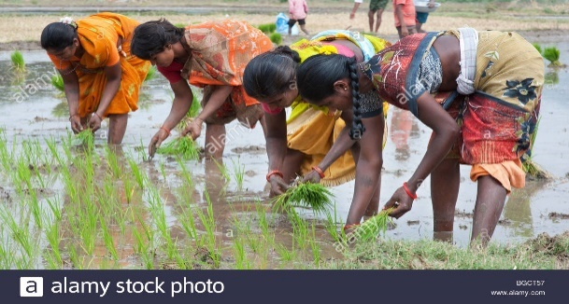 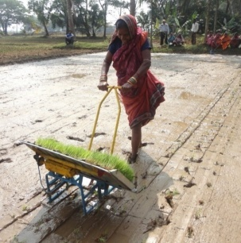

**OBJECTIVES**

1) To study the association between different drudgery and their effect on women’s health.

2) To study the social and economic status of women who are involved in farming work

3) Impact assessment of mini tool bank in drudgery reduction of women.

**METHODOLOGY**

**Source of data**:

Study will be based on *primary data*

**Target Population**:

All women(farming and non farming) of Kareli and Samoj village of Jambusar taluka in Bharuch district.

**Survey Design**

Primary data will be collected through two different ways

i) By questionnaires

ii) By conducting medical camp at both the villages

* Questions on social economic status and different farm activities is included in questionnaires.
* Data for socio-economic status of women will be collected through questionnaires and some health indicators will be measured in medical camp.
* Different farm drudgery need to be done in particular body postures and in a long run it affects women’s body posture very badly. To measure this parameter we are going to perform postural health analysis for different drudgery so that AATAPI foundation can provide different drudgery reduction tool to women which eventually improve their overall health and reduce body ache.

**SAMPLING METHOD**

**‘***Stratified sampling’*  is used to get sample size of both villages.

Study area are two villages having different population,

Frist we have apply simple random sampling to derive total sample size and then by using stratified sampling necessary sample size for kareli and samoj village is derived.

No. of women in Kareli = 2712 (By 2011 census data)

No. of women in Samoj = 717 (By 2011 census data)

By Simple random sampling without replacement,

N = Total Population Size = N1 + N2 = 2712 + 717 = 3429

Alpha = 0.05

Z score = 1.96

Epsilon = Margin of error = 0.05

P = 0.83 = proportion

n = Total Sample size

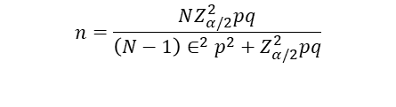

n = 346 (approximately)

Now, we are dividing our sample into two strata. i.e. we are considering kareli and samoj villages as strata.

$n_{i}= \frac{N_{i}}{N} *n$

Village wise sample size:

Table 1:

|  |  |  |  |
| --- | --- | --- | --- |
| **Village** | **Population** | **Sample** | |
| Kareli | 2712 | 227.7795 | 228 |
| Samoj | 717 | 60.2204 | 60 |

*(Source of population by 2011 census data provided by government of india)*

To study the drudgery impact on women’s helth it is necessary to include non-farming women in research, so from both the villages sample size will be further divided into farming and non-farming women.

**ANALYSIS**

* Uday Parekh scale: To find out socio-economic status of women in both villages we are going to use Uday Parekh scale, variables like caste, occupation, education, land holding, family size, housing, social participation will be used.
* Drudgery Index: To decide drudgery level for various farming activities

Drudgery Index = [ (X+Y+Z)/3 ] *100

Where, X = Co-efficient of difficulty felt

Y = Co-efficient of time spent in particular farm activity

Z= coefficient of frequency of performance

* If drudgery index is high for some activity, we can say that, corresponding activity is highly drudgery prone activity.
* REBA and RULA :
* REBA stands for Rapid Entire Body Assessment and
* RULA stands for Rapid Upper Limb Assessment

As mention above women doing farm activity by using traditional method can cause postural health problems. To find out risk factor related to various body postures we will assign a score for each body regions like wrists, forearms, elbows, shoulders, neck, trunk, back, legs and knees. After that data for each region is collected and scored, tables given below are then used to compile the risk factor variables, generating single score that represents the level of MSD (musculoskeletal disorders).

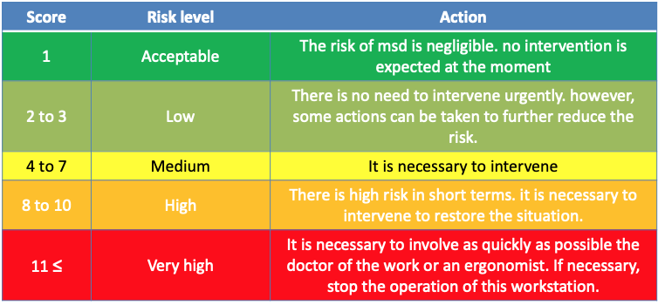

* **Statistical tools**
* Exploratory analysis : Graphical representation of data
* Normality test : To decide whether data normally distributed or not
* Correlation coefficient : To check is there any correlation between various drudgery activities and health parameters
* ANOVA : To test mean time for different drudgery activities
* Chi-square test
* Multiple linear regression : To build model between drudgery index and different health parameters

**REFERENCES**

1. <https://www.researchgate.net/publication/323147882_Impact_of_Drudgery_Reducing_Technologies_among_Farmwomen_of_Gorakhpur_and_Deoria_districts_of_U_P>
2. <https://www.researchgate.net/publication/337903792_Drudgery_reduction_for_women_in_agriculture_sector_in_Nepal_An_analytical_study>
3. A Step-by-Step Guide **Rapid Entire Body Assessment (REBA) (**[**www.ergo-plus.com**](http://www.ergo-plus.com)**)**
4. Research Article AWARENESS AND ADOPTION OF DRUDGERY REDUCING TECHNOLOGIES AMONG FARM WOMEN OF DANTIWADA TALUKA (SUMITRA SUNDHESHA, AHLAWAT SANTOSH AND SINGH SURABHI)
5. A case study on women reducing drudgery through empowerment in agriculture in Dangs of Gujarat (G.J. BHIMANI AND C.S. DESAI)